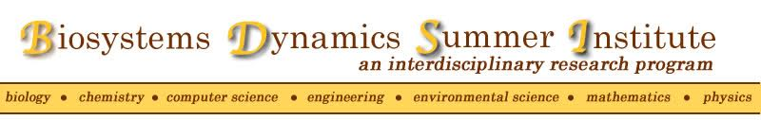

Do you major in one of the following areas?
- behavioral neuroscience  - biochemistry  - bioengineering  - biology  - chemistry  - chemical engineering  - computer science | - earth & environmental science  - electrical & computer engineering  - materials sciences & engineering  - mathematics  - mechanical engineering  - molecular biology  - physics
**Apply for a paid summer internship opportunity**
The Biosystems Dynamics Summer Institute is a 10-week summer program that includes:
- an intensive research experience with a STEM faculty mentor
- workshops for writing and presentation skills seminars
- a $4500 stipend and an allowance for research supplies
To learn more about the Biosystems Dynamics Summer Institute and to access the application form:

https://hhmi.cas2.lehigh.edu/content/biosystems-dynamics-summer-institute

The application deadline is February 8, 2019 at noon

